AUTOMATIC WALL PAINTING ROBOT

A MINI PROJECT REPORT

***Submitted by***

|  |  |
| --- | --- |
| **SRINITHI M** | **(8115U21EE045)** |
| **SWETHA G** | **(8115U21EE046)** |
| **THRISHA S** | **(8115U21EE049)** |
| **YAZHINI K** | **(8115U21EE054)** |

***In partial fulfillment for the award of the degree of***

# BACHELOR OF ENGINEERING

***in***

ELECTRICAL AND ELECTRONICS ENGINEERING



K. RAMAKRISHNAN COLLEGE OF ENGINEERING

TRICHY

(AUTONOMOUS)

# ANNA UNIVERSITY: CHENNAI 600 025

AUGUST 2023

## INSTITUTE VISION AND MISSION

**VISION**

“To achieve a prominent position among the top technical institutions”

## MISSION

* To bestow standard technical education par excellence through state-of-the-art infrastructure, competent faculty and high ethical standards.
* To nurture research and entrepreneurial skills among students in cuttingedge technologies.
* To provide education for developing high-quality professionals to transform the society.

## DEPARTMENT VISION AND MISSION

**VISION**

To emerge as a renowned department for high quality teaching, learning and research in the domain of Electrical and Electronics Engineering, producing professional engineers, to meet the challenges of society.

## MISSION

M1. To establish the infrastructure resources for imparting quality technical education in Electrical and Electronics Engineering.

M2. To achieve excellence in teaching, learning, research and development.

M3. To impart the latest skills and developments through practical approach along with moral and ethical values.

## PROGRAM SPECIFIC OUTCOMES (PSOs)

**PSO1:** Apply the logical, analytical and technical skills to model and build electrical systems and appliances as per societal requirements.

**PSO2:** Apply the advanced and fundamentals Electrical and allied Engineering knowledge in the design and development of hardware and software tools for non-conventional electrical power generation and distribution.

**PROGRAM EDUCATIONAL OBJECTIVES (PEOs)**

PEO1: Have strong foundation in Electrical and Electronics Engineering to excel in professional career, in higher studies or research.

PEO2: Analyze, design and develop various interdisciplinary projects and products, to solve industrial needs and social issues.

PEO3: Have professional ethics and effective communication skills with life-long learning attitudes.

## PROGRAM OUTCOMES (POs)

PO1 :Engineering knowledge: Apply the knowledge of mathematics, science, engineering fundamentals, and an engineering specialization to the solution of complex engineering problems.

PO2 :Problem analysis: Identify, formulate, review research literature, and analyze complex engineering problems reaching substantiated conclusions using first principles of mathematics, natural sciences, and engineering sciences.

PO3 :Design/development of solutions: Design solutions for complex engineering problems and design system components or processes that meet the specified needs with appropriate consideration for the public health and safety, and the cultural, societal, and environmental considerations.

**PO4 :**Conduct investigations of complex problems: Use research-based knowledge and research methods including design of experiments, analysis and interpretation of data, and synthesis of the information to provide valid conclusions.

PO5 :Modern tool usage: Create, select, and apply appropriate techniques, resources, and modern engineering and IT tools including prediction and modeling to complex engineering activities with an understanding of the limitations.

PO6 :The Engineer and Society: Apply reasoning informed by the contextual knowledge to assess societal, health, safety, legal and cultural issues and the consequent responsibilities relevant to the professional engineering practice.

PO7 :Environment and sustainability: Understand the impact of the professional engineering solutions in societal and environmental contexts, and demonstrate the knowledge of, and need for sustainable development.

PO8 :Ethics: Apply ethical principles and commit to professional ethics and responsibilities and norms of the engineering practice.

**PO9 :**Individual and team work: Function effectively as an

individual, and as a member or leader in diverse teams, and in multidisciplinary settings.

PO10 :Communication: Communicate effectively on complex engineering activities with the engineering community and with society at large, such as, being able to comprehend and write effective reports and design documentation, make effective presentations, and give and receive clear instructions.

PO11 :Project management and finance: Demonstrate knowledge and understanding of the engineering and management principles and apply these to one’s own work, as a member and leader in a team, to manage projects and in multidisciplinary environments.

PO12 :Life-long learning: Recognize the need for, and have the preparation and ability to engage in independent and life-long learning in the broadest context of technological change.

## COURSE OUTCOMES:

|  |  |  |  |
| --- | --- | --- | --- |
| **S.NO** | **BLOOMS LEVEL** | **DESCRIPTION** | **PO(1..12)**  **&PSO(1..2) MAPPING** |
| C318.1 | K3 | To expose the students to apply knowledge to solve problems. | PO1, PSO1 & PSO2 |
| C318.2 | K3 | To expose the students to find solutions to complex problems, issues for public and environmental concerns. | PO3, PO7, PSO1 & PSO2 |
| C318.3 | K3 | To expose the students to give conclusion, analyses methods for various scenarios. | PO4, PSO1 & PSO2 |
| C318.4 | K2 | To expose the students to communicate efficiently their technical knowledge and concepts. | PO9, PO10 & PSO2 |
| C318.5 | K2 | To expose the students to self-learning and long-term learning process. | PO12 & PSO1 |

**COURSE OUTCOMES VS POS MAPPING**

**(**DETAILED; HIGH: 3; MEDIUM: 2; LOW: 1**):**

|  |  |  |  |  |  |  |  |  |  |  |  |  |  |  |
| --- | --- | --- | --- | --- | --- | --- | --- | --- | --- | --- | --- | --- | --- | --- |
| **SNO** | **PO1** | **PO2** | **PO3** | **PO4** | **PO5** | **PO6** | **PO7** | **PO8** | **PO9** | **PO10** | **PO11** | **PO12** | **PSO1** | **PSO2** |
| **C318.1** | **3** | **-** | **-** | **-** | **-** | **-** | **-** | **-** | **-** | **-** | **-** | **-** | **2** | **3** |
| **C318.2** | **-** | **-** | **3** | **-** | **-** | **-** | **3** | **-** | **-** | **-** | **-** | **-** | **2** | **3** |
| **C318.3** | **-** | **-** | **-** | **3** | **-** | **-** | **-** | **-** | **-** | **-** | **-** | **-** | **2** | **3** |
| **C318.4** | **-** | **-** | **-** | **-** | **-** | **-** | **-** | **-** | **3** | **3** | **-** | **-** | **-** | **2** |
| **C318.5** | **-** | **-** | **-** | **-** | **-** | **-** | **-** | **-** | **-** | **-** | **-** | **3** | **2** | **-** |

*\* For Entire Course, PO /PSO Mapping; 1 (Low); 2(Medium); 3(High) Contribution to PO/PSO*

**ANNA UNIVERSITY: CHENNAI 600 025**

# BONA FIDE CERTIFICATE

##### Certified that this project report “**AUTOMATIC WALL PAINTING ROBOT”** is the bona fide work of **SRINITHI .M (8115U21EE045), SWETHA.G(8115U21EE046), THRISHA.S(8115U21EE049), YAZHINI.K(8115U21EE054),** who carried out the project work under my supervision. Certified further that to the best any knowledge the work reported herein does not form part of any other thesis or dissertation on the basis of which a degree or award was conferred on an earlier occasion on this or any other candidate.

## SIGNATURE SIGNATURE

Mr.G.Gabriel Santhosh Kumar, Mr.A. Jainulafdeen,

M.E., (PhD) M.E., (PhD)

## HEAD OF THE DEPARTMENT Project Supervisor

## Assistant Professor Assistant Professor

Electrical and Electronics Electrical and Electronics Engineering Engineering

K.Ramakrishnan College of K.Ramakrishnan College of Engineering(Autonomous) Engineering(Autonomous)

Samayapuram, Samayapuram,

Trichy-621 112. Trichy-621 112.

This mini-project report was submitted for the viva-voce examination held on …………………. at K. Ramakrishnan College of Engineering, Trichy-621112.

**INTERNAL EXAMINER EXTERNAL EXAMINER**

## ACKNOWLEDGEMENT

We thank the Almighty God, for showing abundance of grace, without his blessings it would not have been possible for us to complete our mini-project.

At this pleasing moment of having successfully completed our mini-project, we wish to convey our sincere thanks and gratitude to our beloved kind Chairman Dr. K. RAMAKRISHNAN, who provided all the facilities to us.

Our sincere gratitude to Dr. S. KUPPUSAMY, Executive Director for his constant encouragement. We are also grateful to our Principal Dr. D. SRINIVASAN, for his constructive suggestions and encouragement during our project.

We wish to express the profound thanks to Mr. G. GABRIEL SANTHOSH KUMAR, M.E., (PhD), Assistant Professor and Head, Department of Electrical & Electronics Engineering, for providing all necessary facilities for doing this project.

We whole heartedly acknowledge our deep sense of gratitude and indebtedness to our beloved guide Mr . A. JAINULAFDEEN, M.E., (PhD), Assistant Professor , for his expert guidance and encouragement throughout the duration of the project.

We extend our gratitude to all the teaching & Non–teaching staff members of Electrical & Electronics Engineering Department, **K. RAMAKRISHNAN COLLEGE OF ENGINEERING** for their kind help and valuable support to complete the project successfully. We would like to thank our parents and friends for their constant support and encouragement throughout this project.

**ABSTRACT**

The abstract automatic wall painting robot is an innovative robotic system designed to autonomously paint walls with precision and efficiency. Incorporating advanced technologies such as robotics, computer vision, and possibly artificial intelligence, this robot navigates spaces, detects obstacles, and accurately applies paint according to predefined parameters. Its abstract nature may involve the interpretation of artistic instructions or the ability to adapt its painting style, offering a blend of functionality and creativity in automated wall painting tasks.

**LIST OF ABBREVATIONEM** ENERGY METER

**SEM** SMART ENERGY METER

**IOT** INTERNET OF THINGS

**DC** DIRECT CURRENT

**AC** ALTERNATIVE CURRENT

**IC** INTEGRATED CIRCUIT

**SOC** SYSTEM ON CHIP

**LCD** LIQUID CRYSTAL DISPLAY

**IDE**   INTEGRATED DEVELOPMENT ENVIRONMENT

**LIST OF FIGURES**

|  |  |  |
| --- | --- | --- |
| **FIGURE**  **NO.** | **TITLE** | **PAGE NO.** |
| 3.1 | BLOCK DIAGRAM | 6 |
| 4.1 | CURRENT SENSOR | 8 |
| 4.2 | VOLTAGE SENSOR | 9 |
| 4.3 | ESP-8266 WI-FI MODULE | 10 |
| 4.4 | 16*2 LCD DISPLAY | 11 |
| 4.5 | ARDUINO UNO | 13 |
| 4.6 | I2C PROTOCOL | 15 |
| 4.7 | ARDUINO IDE | 16 |
| 5.1 | HARDWARE CIRCUIT | 25 |
| 5.2 | POWER GRAPH | 26 |
| 5.3 | VOLTAGE AND CURRENT GRAPHS | 26 |

**TABLE OF CONTENTS**

|  |  |  |
| --- | --- | --- |
| **CHAPTER**  **NO.** | **TITLE** | **PAGE**  **NO.** |
|  | **ABSTRACT** | x |
|  | **LIST OF ABBREVIATIONS** | xi |
|  | **LIST OF FIGURES** | xii |
| **1** | **INTRODUCTION** | 1 |
| **2** | **LITERATURE SURVEY**  MERITS&DEMIRITS  OF ENERGY METER | 3 |
| **3** | CONCEPTUAL OF IOT BASED SMART ENERGY METER  3.1 BLOCK DIAGRAM OF IOT BASED SMART ENERGY METER  3.2EXPLANATION OF IOT BASED SMART ENERGY METER | 6 |
| **4** | **IMPLEMENTATION OF IOT BASED SMART ENERGY METER**  **4.1HARDWARE REQUIREMENTS**  4.1.1 BLOCK DIAGRAM  4.1.2 CURRENT SENSOR  4.1.3 VOLTAGE SENSOR  4.1.4 ESP-8266 WI-FI MODULE  4.1.5 16*2 LCD DISPLAY  4.1.6 ARDUINO UNO  4.1.7 I2C PROTOCAL  **4.2SOFTWARE REQUIREMENTS**  4.2.1 ARDUINO IDE | 8 |
| **5** | **OVERALL CIRCUIT DIAGRAM DESCRIPTION**  5.1 CONNECTION PROCEDURE  5.2 WORKING  5.3 CODING | 17 |
|  | **CONCLUSION AND FUTURE ASPECTS**  **REFERENCE**  **HARDWARE & OUTPUT**  **APPENDICES** | 20 |

**CHAPTER 1**

**INTRODUCTION**

The introduction for an automatic wall painting robot would serve to provide an overview of the robot's purpose, significance, and capabilities. Here's a brief introduction:

In recent years, advancements in robotics and automation have revolutionized various industries, offering solutions to streamline processes and improve efficiency. Among these innovations, the automatic wall painting robot stands out as a groundbreaking technology poised to transform the construction and painting sectors. This robotic system represents a significant leap forward in the automation of traditionally labor-intensive tasks, offering the potential to enhance productivity, reduce costs, and elevate the quality of painted surfaces. By integrating cutting-edge technologies such as robotics, computer vision, and potentially artificial intelligence, this robot promises to revolutionize the way walls are painted, introducing a new era of precision, speed, and adaptability. In this brief explanation, we delve into the key features and potential applications of the automatic wall painting robot, highlighting its role as a game-changer in the field of automated construction and painting

This introduction effectively sets the stage for discussing the automatic wall painting robot. It provides context by acknowledging recent advancements in robotics and automation, positioning the robot as a significant innovation within this landscape. It outlines the purpose of the robot—to revolutionize construction and painting sectors through automation—and highlights its potential benefits, such as enhanced productivity and improved quality. By mentioning the integration of cutting-edge technologies like robotics, computer vision, and artificial intelligence, it emphasizes the robot's sophistication and potential for advancement. Overall, this introduction effectively introduces the topic and sets the tone for further exploration of the automatic wall painting robot's capabilities and implications.

**1.1 POWER SUPPLY**

**1.1.1 FUNCTIONAL OF POWER SUPPLY**

A power supply for an automatic wall painting robot would need to meet certain functional requirements to ensure the robot operates efficiently and safely. Here's a breakdown of the functional aspects such a power supply might entail:

**Voltage and Current Ratings**:

The power supply should provide the required voltage and current levels to drive the motors, actuators, sensors, and other electronic components of the robot. These specifications would depend on the specific design and requirements of the robot.

**Stability and Regulation:**

The power supply should deliver stable output voltage and current to ensure consistent performance of the robot's components. Regulation circuitry can help maintain a steady output despite fluctuations in input voltage or load changes.

**Safety Features**:

The power supply should incorporate safety features such as overcurrent protection, overvoltage protection, and short-circuit protection to prevent damage to the robot and ensure user safety.

**Efficiency:**

A high-efficiency power supply can help minimize energy waste and heat generation, which is particularly important for battery-powered robots to prolong operating time.

**Compactness and Portability:**

Depending on the application, the power supply should be designed to be compact and lightweight for easy integration into the robot's chassis. If the robot is mobile, portability becomes a key consideration.

**Compatibility:**

The power supply should be compatible with the power sources available in the intended operating environment (e.g., AC mains power, batteries, etc.).

**EMI/RFI Filtering:**

Electromagnetic interference (EMI) and radio frequency interference (RFI) can disrupt the operation of sensitive electronic components in the robot. The power supply should incorporate filtering to reduce these interferences.

**Heat Dissipation:**

If the power supply generates significant heat during operation, it should include adequate heat dissipation mechanisms such as heatsinks or fans to prevent overheating.

**Remote Monitoring and Control:**

For advanced applications, the power supply may include features for remote monitoring and control, allowing operators to check the status of the power supply and adjust settings as needed.

**Robustness and Reliability:**

The power supply should be designed to withstand the rigors of the operating environment, including vibrations, shocks, and temperature variations, to ensure reliable operation over the robot's lifespan.

By addressing these functional aspects, the power supply can effectively support the operation of an automatic wall painting robot, providing the necessary electrical power while ensuring safety, efficiency, and reliability.

### 1.1.3 TYPES OF POWER SUPPLY

**1.1.3.1 DC POWER SUPPLY**

A DC power supply is one that supplies a constant DC voltage to its load. Depending on its design, a DC power supply may be powered from a DC source or from an [AC](https://en.wikipedia.org/wiki/Alternating_current) source such as the power mains.

### 1.1.3.2 AC-TO-DC SUPPLY

DC power supplies use AC [mains electricity](https://en.wikipedia.org/wiki/Mains_electricity) as an energy source. Such power supplies will employ a [transformer](https://en.wikipedia.org/wiki/Transformer) to convert the input voltage to a higher or lower AC voltage. A [rectifier](https://en.wikipedia.org/wiki/Rectifier) is used to convert the transformer output voltage to a varying DC voltage, which in turn is passed through an [electronic filter](https://en.wikipedia.org/wiki/Electronic_filter) to convert it to an unregulated DC voltage.

The filter removes most, but not all of the AC voltage variations; the remaining AC voltage is known as ripple. The electric load's tolerance of ripple dictates the minimum amount of filtering that must be provided by a power supply. In some applications, high ripple is tolerated and therefore no filtering is required. For example, in some battery charging applications it is possible to implement a mains- powered DC power supply with nothing more than a transformer and a single rectifier diode, with a resistor in series with the output to limit charging current.

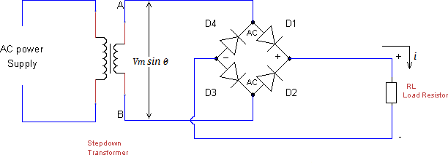

Fig: 1.1.3 Bridge Rectifie

**CHAPTER 2**

**LITERATURE SURVEY**

Reference [1] Amgad Muneer : Design and implementation of automatic painting mobile robot - March 2021 Wall painting is a repetitive, stressful, and hazardous process that makes it an ideal automation case. In the automotive industry, painting had been automated but not yet for the construction industry. However, there is a strong need for a mobile robot that can move to paint residential interior walls. In this study, we aim to design and implement an automatic painting mobile robot. The conceptual design of the proposed wall painting robot consisting paint mechanism with a spray gun and ultrasonic sensor.

Reference [2] Atharva C. Paralikar : Spray-Painting Robot for Painting Irregular Workpieces -June 2019 The present research paper aims at design of a cost-effective Spray-Painting Robot which is capable of painting irregular workpieces with highly contoured surfaces. With advent of Electrostatic spray- painting techniques, it is imperative to automate the painting process due to the electrical hazardsposed. Intelligent Robotic systems use for painting need complex path planning algorithms and thus can become very costly.

Reference [3] Swetha Danthala: Automatic Spray Painting Robot using Regression Method - Jan 2020 The main of the paper is to take up parametric optimization for an automatic spray painting robot which helps to reduce operational cost and time. The painting chemicals can cause hazards to the painters such as eye and respiratory system problems. When construction workers the robots are properly used in buildings and whole construction process can be better manage to savings the human labor and timing by applying the machine learning techniques we find out the surface roughness thickness variation.

Reference [4] B Sai Krishnan : Fabrication of Automatic Wall Painting Machine May 2019 The primary aim of the project is to design, develop and implement Automatic Wall Painting Robot which helps to achieve low cost painting equipment. Despite the advances in robotics and its wide spreading applications, interior wall painting has shared little in research activities. The painting chemicals can cause hazards to the human painters such as eye and respiratory system problems.

Reference [5] Citación sugerida : Development Of Smart Painting Machine Using Image Processing - 2021 Painting is a process in automotive industry that takes about 10% of the total time consumed per vehicle. Currently, the painting lines in several automotive industries like Toyota motors or General motors is largely being automated after implementation of robotic arms. However, according to the study done, this automation is restricted to paint main body or chassis only, the coating and painting on small vehicle parts is still done manually.

Reference [6] Utkarsha S. Bawane : Automatic Wall Painting Machine - Feb 2018 The use of spraying robotized systems for interior painting was already shown to be feasible and convenient, a lot of experiments must be carried out in the future to deliver a highly autonomous robot for interior painting. We developed an exterior wall painting robot for the purpose of automating this painting operation. The robot is mounted on equipment which permits it to move up and down, left and right along the exterior walls of a building. It is computer controlled and is activated simply by the operator pressing a switch on the control panel located on the ground.

Reference [7] R Monika : Automatic Wall Painting Robot - 2018 During painting process, chemicals in the paint can cause hazards to the human painters such as eye and respiratory system problems. Paint rollers and Paint brushes were used to paint the wall from top to bottom. By repeating the process like pulling the roller and lifting the ladder may cause back ache. These reasons makes us to develop automatic wall painting robot.

Reference [8] Patrick Paetzold : Developments Regarding Painting Robots for Research in Automatic Painting, Artificial Creativity, and Machine Learning - May 2020 E-David (Electronic Drawing Apparatus for Vivid Image Display) is a system for controlling a variety of painting machines in order to create robotic paintings. This article summarizes the hardware set-up used for painting, along with recent developments, lessons learned from past painting machines, as well as plans for new approaches. We want to apply e-David as a platform for research towards improving automatic painting and to explore machine creativity.

Reference [9] Om Prakash Gujela : Six DOF Spray Painting Robot Analysis 2016 Today, different kinds of robots are being used in many fields. Especially in industries, robots are essential. One application in the industries is spray painting task which is no more suitable for human workers because it have large effect on health. Also the spray painting is a challenging task and need significant skill. Thus, spray painting robot are using wider and wider.

Reference [10] Lukumon Oyedele : Robotics and automated systems in construction: Understanding industry specific challenges for adoption - Nov 2019 The construction industry is a major economic sector, but it is plagued with inefficiencies and low productivity. Robotics and automated systems have the potential to address these shortcomings; however, the level of adoption in the construction industry is very low. This paper presents an investigation into the industry-specific factors that limit the adoption in the construction industry.

Reference [11] K. Nuntiya1, C. Seksan1 : A Simulation Model To Optimize The Painting Robots - Feb 2020 Robots have been widely used to replace human labors in the manufacturing factories, especially when dealing with hazardous environments such as chemicals, heat, etc. Other objective including ensuring consistent quality taking advantages of continuous operation of the robots. However, one major hindrance is the high initial investment of the robots despite the benefit acquired when the robots is used. Often, the skeptical opinion of the investors winding down the proposal.

CHAPTER 3

EXISTING SYSTEM

3.1 BLOCK DIAGRAM OF EXISTING SYSTEM

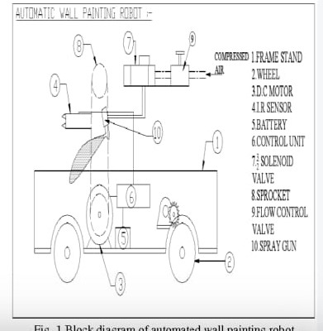

Fig 3.1 Block diagram

**EXISTING SYSTEM ANALYSIS**

One of the processes that is expanding in this sector is construction and building work. In this continuously changing world, construction is increasing quickly. But there isn't enough labour to do this task. More dangerous issues arise while painting tall buildings than when doing interior building work. People now perceive this line of work as being prestigious due to the rise in educational attainment. The labourers are the foundation of the construction work. But that's where the lagging starts. As a result, robotics and automation are progressing more quickly. Every process becomes simpler with the aid of the robot. Here, we create a painting related robot. There are other causes for the labour shortage, including the fact that individuals may perceive these positions as less prestigious than others due to the rise in educational standards.

**CHAPTER 4**

**PROPSED SYSTEM**

**4.1 BLOCK DIAGRAM OF AUTOMATIC WALL PAINTING ROBOT:**

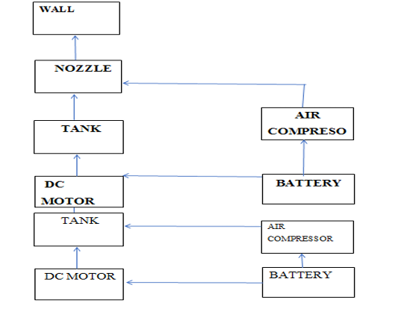

**WORKING**

Planning of the painting process, planning of collision free spray gun motions. Specifies a trajectory of the spray gun, which satisfies the desired paint quality. In this module only spray gun motions are considered in relation to process quality. No restrictions of robots are made and collisions between the spray gun and its surroundings are not considered. The system uses the “Geometry Library” and the “Procedure Library” in order to plan this trajectory. The Geometry Library specifies for each geometric primitive one or more painting procedures, which may be e applied for painting that particular type of geometric primitive. The painting procedure specifies how to apply spray gun motions to the surfaces in order to achieve a satisfactory process quality. The procedure library is established through experimental work. The basic idea is to enable planning of paint strokes that continue throughout the parts even though different geometric primitives must be covered along the surface and even though continuous robot motions cannot follow the surface. The system will attempt to approximate the triangular patches of the surface model by larger plane regions (virtual surfaces), which are oriented in a few main directions. DP/DT switch has an central OFF position, when operated to one of the ON position, the motor will rotate in clockwise direction , operating the worm gear box and thereby the pinion shaft. The pinion rotates to rotate the gear and thereby the main shaft and stand in clockwise direction taking the stand to close position. When other ON position is operated the motor will rotate in counter clockwise direction , operating the worm gear box and thereby the pinion shaft. The pinion rotates to rotate the gear and thereby the main shaft and stand in counter clockwise direction taking the stand to open position.

**CHAPTER 5**

**HARDWARE REQUIREMENTS**

**5.1 ROPOSED METHOD**

The process involves creating a plausible, full, and executable robot programme automatically using range sensor data and robotic paint pathways. The method works with a wide variety of parts, including big compressor tanks, small pieces on frames (such as automobile mirrors, plates, and pipes), and motors with gears. The part families (which can have up to 70.000 variants) are known for each industrial customer (Figure 1). The goal is to be able to paint components in any sequence as they move up the conveyor. Automatically determining the part's geometry while it is being transported presents a technical challenge.

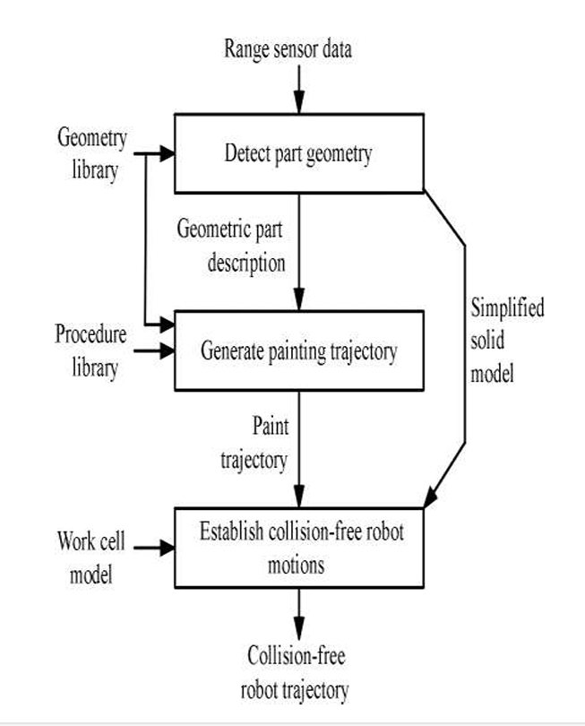

**5.2 MICROCONTROLLER (ATMEGA 328 P)**

A serial programmable USART, a byte-oriented 2-wire serial interface, an SPI serial port, a 6 channel 10-bit A/D converter (8-channels in TQFP and QFN/MLF packages), programmable timer/counters, 23 general-purpose I/O lines, 32 general-purpose working registers, three flexible timer/counters with compare modes, internal and external interrupts, and more are all features of the high-performance Atmel 8-bit AVR RIS The device requires 1.8 to 5.5 volts to operate. Throughputs of over 1 MIPS per MHz are achieved by the device, which balances power consumption and processing performance by carrying out powerful instructions in a single clock cycle.

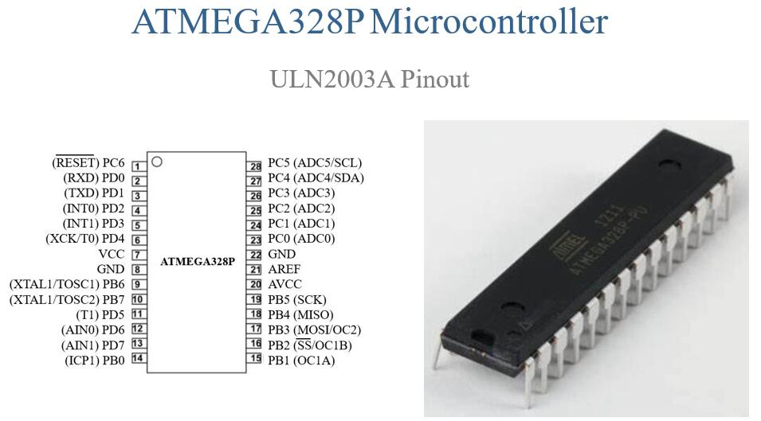

Microcontrollers offer various advantages and disadvantages, depending on the specific application and requirements. Here's an overview of both:

**5.2.1 ADVANTAGES:**

**1. Cost-Effective:** Microcontrollers are generally cost-effective solutions for embedded systems compared to other computing platforms like microprocessors.

**2. Compact Size:** Microcontrollers are integrated circuits containing the processor, memory, and I/O peripherals in a single chip, resulting in compact and space-saving designs.

**3. Low Power Consumption:** Microcontrollers are designed to operate efficiently on low power, making them suitable for battery-powered or energy-efficient applications.

**4. Real-Time Processing:** Many microcontrollers offer real-time processing capabilities, allowing them to respond quickly to input signals and perform tasks with minimal latency.

**5. Ease of Use:** Microcontrollers often come with development tools, software libraries, and a wide range of peripherals, making them relatively easy to program and integrate into embedded systems.

**5.2.2 DISADVANTAGES:**

**1. Limited Processing Power:**Microcontrollers typically have limited processing power and memory compared to microprocessors, which may restrict the complexity and performance of applications.

**2. Limited Peripheral Integration:** While microcontrollers offer a variety of built-in peripherals, they may not always meet the specific requirements of a particular application, necessitating the use of external components.

**3. Limited Connectivity:** Microcontrollers may have limited connectivity options compared to other computing platforms, which can be a limitation in applications requiring extensive communication with external devices or networks.

**4. Single-Threaded Execution:** Most microcontrollers execute code sequentially in a single thread, which may limit their ability to handle concurrent tasks efficiently.

**5. Fixed Functionality:**Once manufactured, the functionality of a microcontroller is fixed and cannot be easily changed or upgraded, which may pose limitations in adapting to evolving requirements or technologies.

**5.3 IR SENSOR**

An electrical gadget that produces infrared light to sense certain features of its environment is called a sensor. Both the heat and motion of an item can be measured by an IR sensor. These kinds of sensors are referred to as passive IR sensors since they do not emit infrared radiation; instead, they merely measure it. Typically, all items emit some type of thermal radiation in the infrared range. Although these radiations are invisible to the human eye, an infrared sensor can pick them up The emitter and detector are both infrared LEDs (Light Emitting Diodes). The only device that can detect IR light with the same wavelength as an IR LED is an IR photodiode. The output voltages and resistances of the photodiode are proportional to the IR light received when it strikes it.

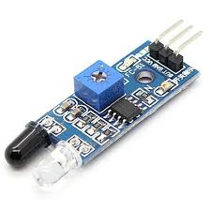

**5.3.1 PRINCIPLES OF OPERATIONS**

A light sensor's operation has already been discussed. IR sensors use a specific light sensor to detect a specific light wavelength in the infrared (IR) spectrum. Using an LED that emits light at the same wavelength as the sensor allows you to gauge the strength of the light that is being received. When an object is close to a light sensor, light from the LED bounces off the object and enters the sensor. This significantly raises the intensity, This can already be determined using a threshold. Since the sensor looks for reflected light in order to work, it is possible to have a sensor that can return the value of the reflected light. This type of sensor can then be used to gauge the object's "brightness." It's useful for tasks like line tracking.

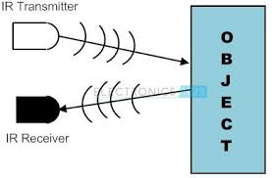

**5.4 LED**

LED stands for Light Emitting Diode. It's a semiconductor device that emits light when an electric current passes through it. LEDs are widely used in various applications due to their efficiency, durability, and compact size. Unlike traditional incandescent bulbs, which generate light by heating a filament, LEDs produce light through a process called electroluminescence, where electrons recombine with electron holes within the device, releasing energy in the form of photons (light). LEDs come in various colors, including red, green, blue, white, and other colors, depending on the materials used in their construction. They are commonly used for lighting in homes, offices, automobiles, electronic displays, indicators, signage, and many other applications.

**5.4.1 OPERATION OF LED:**

LED operation in a remote control car typically involves controlling the lighting system of the car using the remote control. Here's how you might typically operate LED lights in a remote control car:

**1. Power On:** Ensure that both the remote control and the car are powered on and connected.

**2. Locate LED Controls:** Check your remote control for buttons or switches dedicated to controlling the LED lights. These may be labeled specifically for lights or have symbols representing light functions.

**3. Toggle Lights On/Off:** Press the appropriate button or switch to toggle the LED lights on or off. Some remote control cars may have multiple sets of LED lights, such as headlights, tail lights, and auxiliary lights, each controlled separately.

**4. Adjust Brightness or Modes (if applicable):** In some advanced models, you might be able to adjust the brightness of the LED lights or switch between different lighting modes like steady, flashing, or strobe effects. Refer to your remote control's user manual for instructions on how to access these features.

**5. Syncing with Remote:** If your LED lights are not responding to the remote control, check for any synchronization procedures in the user manual. Sometimes, you may need to pair or sync the lights with the remote control to establish a connection.

**6. Safety Considerations:** When operating LED lights on a remote control car, especially if driving at night or in low-light conditions, ensure that you maintain visibility and avoid dazzling other drivers or pedestrians with overly bright lights.

**7. Battery Life:** LED lights can consume additional power from the car's battery, so be mindful of your usage to avoid draining the battery too quickly. Consider turning off the lights when not needed to conserve power.

Operating LED lights in a remote control car can add an extra layer of excitement to your driving experience, especially during nighttime driving or for adding realism to scale models. Enjoy experimenting with different lighting effects and customizations to enhance your remote control car hobby!

**5.5 PURPOSE OF WHEELS**

The wheels in a remote control car serve several essential purposes, just like the wheels in a full-sized car:

**1. Mobility:** The primary purpose of wheels in a remote control car is to provide mobility and movement. They enable the car to roll along various surfaces such as pavement, dirt, grass, or even rocky terrain, depending on the design and capabilities of the car.

**2. Steering:** Wheels play a crucial role in steering the remote control car. By turning the front wheels, the driver can change the direction in which the car travels. This allows for precise control and maneuverability, essential for navigating around obstacles, making sharp turns, and completing courses or tracks.

**3. Traction:** The design and quality of the wheels greatly affect the car's traction or grip on the surface. Traction is crucial for maintaining control and stability, especially when accelerating, braking, or cornering. Different types of wheels, such as those with treads or specialized rubber compounds, may be used to optimize traction for specific terrain conditions.

**4. Suspension Support:** In many remote control cars, especially those designed for off-road use or rough terrain, the wheels are part of the suspension system. They help absorb impacts and unevenness in the ground, providing a smoother ride and preventing excessive stress on the car's chassis and components.

**5. Aesthetics**: While not strictly functional, the appearance of the wheels can significantly impact the overall look and style of the remote control car. Many hobbyists and enthusiasts enjoy customizing their cars with different wheel designs, colors, and finishes to enhance their visual appeal and personalization.

Overall, the wheels are essential components of a remote control car, contributing to its performance, handling, and appearance. Their design and functionality directly influence how the car moves and responds to the driver's inputs, making them integral to the overall driving experience.

**5.6 OPERATION OF MOTOR**

Operating the motor in a remote control car involves controlling its speed, direction, and other functionalities through the remote control transmitter. Here's a basic guide on how to operate the motor in a typical remote control car:

**1. Power On:** Make sure both the remote control transmitter and the car itself are powered on and properly paired.

**2. Throttle Control:** The throttle control on the remote is responsible for controlling the speed of the motor. It's usually a trigger or a dial that you push or turn to accelerate or decelerate the car. Pushing it forward increases speed, while pulling it back slows down or reverses the car.

**3. Steering Control:** The steering control on the remote allows you to control the direction of the car. It's typically a wheel or a pair of buttons that you use to turn the car left or right. Practice steering the car smoothly to navigate it around obstacles and corners.

**4. Proportional Control:** Many modern remote control cars feature proportional control, which means the speed and steering inputs are proportional to how much you push or turn the controls. This allows for more precise and realistic driving experience.

**5. Dual-Rate Adjustment (if applicable):** Some remote control transmitters have dual-rate adjustment knobs or settings that allow you to adjust the sensitivity of the throttle and steering controls. Experiment with these settings to find the right balance between responsiveness and stability based on your driving skill level and preferences.

**6. Braking and Reverse:** Familiarize yourself with how to apply brakes and engage reverse gear if your remote control car has these features. Typically, pulling the throttle trigger all the way back activates the brakes, while pushing it beyond neutral engages reverse.

**7. Safety Precautions**: Always operate your remote control car in a safe and open area away from traffic, pedestrians, and obstacles. Be mindful of your surroundings and avoid driving near fragile objects or surfaces that could damage the car.

**8. Battery Management:** Monitor the battery level of both the car and the remote control transmitter to prevent unexpected shutdowns during operation. Recharge or replace batteries as needed to maintain optimal performance.

**9. Practice and Enjoy:** Practice operating the motor in your remote control car to improve your driving skills and enjoy the experience of controlling your vehicle with precision and finesse.

By mastering the operation of the motor in your remote control car, you can unlock its full potential for fun and excitement, whether you're racing, performing stunts, or simply enjoying leisurely drives.

**CHAPTER 6**

**CONCLUSION**

A smart energy meter is an advanced version of a traditional energy meter that measures and records energy consumption in real-time. Smart meters are designed to help consumers better understand their energy usage patterns, reduce energy consumption and ultimately save money on their energy bills. IoT-based energy meters offer several benefits over traditional energy meters. Here are some of the key needs for IoT-based energy meters:

* Real-time monitoring
* Remote access
* Predictive maintenance
* Energy efficiency
* Demand Response

Overall, IoT-based energy meters offer a more efficient and effective way to monitor energy consumption, reduce energy waste, and improve energy efficiency.

We have studied well about the project work of automatic wall painting robot. We wish to complete this project in section wise. As a first step by taking some approximate measure we designed a painting robot structure and components to be used and their ratings. After that for choosing the main component motor is depended up on the net weight of the system.

By taking approximate weight we chose the motor ratings. . To initiate the project this project hardware in seventh semester, we fabricated the frame and slide screw for wall painting robot. The remaining works of project done in eight semester. It includes the purchasing of components such as battery, motor, nozzle, spray painting gun and switches. Fabricated all this components, design and its testing make practice for its painting.

**CHAPTER 7**

**FUTURE ASPECTS**

Smart energy meters have a promising future and are expected to play a vital role inside the transformation of the energy sector. Here are some views on the destiny of smart energy meters:

1. **Energy Efficiency:** Smart electricity meters allow actual-time monitoring of power intake, permitting users to become aware of wasteful electricity usage patterns. With this information, people and agencies can make knowledgeable choices to optimize their electricity usage and enhance energy performance. This, in turn, can cause big power savings and reduced carbon emissions.
2. **Demand Response:** Smart electricity meters facilitate call for response applications, where energy carriers can modify pricing based totally on height and stale-peak hours. Consumers can acquire real-time statistics about energy costs and adjust their utilization as a consequence. This enables balance the call for and supply of strength, reduces pressure on the grid at some point of top periods, and promotes a extra solid and efficient energy machine.
3. **Renewable Energy:** As renewable energy assets like sun and wind electricity emerge as more usual, smart strength meters will play a crucial role in integrating these intermittent energy resources into the grid. By supplying actual-time facts on electricity technology and intake, smart meters permit higher management and coordination of renewable electricity resources, improving grid balance and reliability.

**4)Advanced Analytics and AI:** Smart strength meters generate a considerable amount of records, which may be leveraged through superior analytics and artificial intelligence (AI) algorithms. This records can provide valuable insights into electricity consumption styles, grid overall performance, and predictive protection. AI-powered algorithms can help become aware of anomalies, optimize power distribution, and decorate overall gadget performance.

**5)Peer-to-Peer Energy Trading:** Smart energy meters, blended with blockchain generation, have the capability to permit peer-to-peer energy buying and selling. Energy clients can generate surplus strength thru rooftop solar panels or different renewable assets and sell it at once to their friends or neighborhood groups. This decentralized method to strength buying and selling can promote renewable energy adoption, empower character clients, and create more resilient and bendy power systems.

1. **Consumer Empowerment:** Smart energy meters empower purchasers by imparting them with designated data about their electricity intake and related charges. This transparency lets in customers to make more knowledgeable decisions about their energy utilization, helping them store cash and reduce their environmental footprint. Consumers can also get right of entry to this statistics thru cellular apps or web portals, allowing them to display and control their power usage remotely.

Overall, the destiny of clever electricity meters seems promising, with the potential to revolutionize power control, promote energy performance, and facilitate the mixing of renewable power sources. Continued advancements in era, facts analytic, and coverage frameworks will further decorate the abilities and impact of clever strength meters within the coming years.

**CHAPTER 8**

**REFERENCES**

* Smart energy and data/information metering system and method

[https://patents.google.com/patent/US10645770B2/en?q=(energyme](https://patents.google.com/patent/US10645770B2/en?q=(energy+me)ter)&oq=energy+meter&page=4

* Electric power system control with measurement of energy demand and energy efficiency

https://patents.google.com/patent/US10666048B2/en?q=(smart+energy+meter)&oq=smart+energy+meter&page=14

* YoMo - The Arduino-based Smart Metering Board Christoph Klemenjak, Dominik Egarter, and Wilfried Elmenreich Institute of Networked and Embedded Systems Alpen-

Adria Universit at Klagenfurt , Austria {name.surname}@aau.at

* A Novel Approach for Automatic Monitoring of Power Consumption using Smart Meter P. Saraswathi1, M. Prabha2

[http://www.mobilegpsonlne.com/downloads/GM28-](http://www.mobilegpsonline.com/downloads/GM28-)29%20Datasheet%20R1G.pdf

<http://www.mobilegpsonline.com/GSMJC01Spec.pdf>

<http://www.visualgsm.com/wire_sms_index.htm>

<http://en.wikipedia.org/wiki/Gsm>

* Himshekhar Das, L.C.Saikia, “GSM Enabled Smart Energy Meter. Ofoegbu Osita Edward, “An Energy Meter Reader with Load Control Capacity.
* Yingying Cheng, Huaxiao Yang, Ji Xiao, Xingzhe Hou, “Running State Evaluation Of Electric Energy Meter”,
* Sahana M N, Anjana S, AnkithS,K Natarajan, K R Shobha, “Home energy management leveraging open IoT protocol stack, IEEE 2015.
* LuigiMartirano,MatteoManganelli,DaniloSbordone,‘‘Design and classification , IEEE 2015.
* J. Widmer, Landis,” Billing metering using sampled values”, IEEE 2014.
* Cheng Pang,ValierryVyatkin,Yinbai Deng, Majidi Sorouri, “Virtual smart meter IEEE 2013.

.